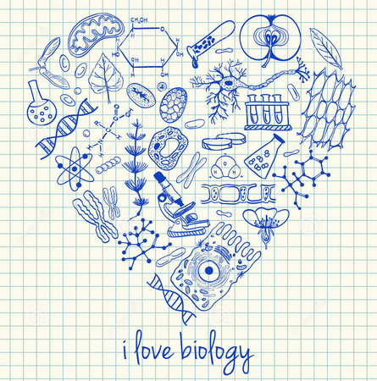
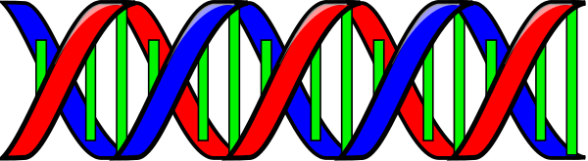
PLANO HIGH SCHOOL
COURSE: Honors Biology
TEXT: Prentice Hall Biology
INSTRUCTOR: Karen Franks
Email: kfranks@plano88.org
Phone: (630) 552-3178
Room: F211
Website: franksbiology.weebly.com
quia.com/profiles/kfranks

COURSE DESCRIPTION: Biology is the study of living things. This is a problem-based, laboratory oriented, minds on course. Honors biology is a weighted course. The course is faster-paced and covers topics more in depth than the biology course.

COURSE OBJECTIVES AND REPRESENTATIVE PERFORMANCE SKILLS: The student coming into this class should have a basic understanding of the scientific method, be able to graph and read rulers, and know basic lab tools with a brief review.

COURSE OUTLINE:
Semester 1 | Semester 2
- Scientific Method/ Graphing/ What is life  - Cell division  - Genetics  - Molecular Genetics (Protein synthesis/ DNA Replication) | - Biochemistry  - Energetics (Photosynthesis/ Cellular Respiration)  - Ecology  - Evolution  - Taxonomy

EXPECTED OUTCOMES: (based on the NGSS and ACT Course Standards for Biology)
The student will…
- Develop and use a model to illustrate the hierarchical organization of interacting systems that provide specific functions within multicellular organisms.
- Plan and conduct an investigation to provide evidence that feedback mechanisms maintain homeostasis.
- Use a model to illustrate the role of cellular division (mitosis) and differentiation in producing and maintain complex organisms.
- Describe the basic process of meiosis and explain how the process of meiosis reveals the mechanism behind Mendel’s conclusions about segregation and independent assortment on a molecular level.
- Construct and interpret Punnett squares and pedigree charts (e.g., calculate and predict phenotypic and genotypic ratios and probabilities).
- Ask questions to clarify relationships about the role of DNA and chromosomes in coding the instructions for characteristic traits passed from parents to offspring.
- Explain and diagram how energy flows through ecosystems in one direction, from photosynthetic organisms to herbivores to carnivores and decomposers (using food webs, food chains, and pyramids).
- Describe the growth of populations, including exponential and logistic growth (e.g., design and conduct an experiment investigating bacterial growth using appropriate calculations)
- Use a model to illustrate the role of photosynthesis and cellular respiration in the cycling of carbon among the biosphere, atmosphere, hydrosphere, and geosphere.
- Construct an explanation based on evidence that the process of evolution primarily results from four factors: (1) the potential for a species to increase in number, (2) the heritable genetic variation of individuals in a species due to mutation and sexual reproduction, (3) competition for limited resources, and (4) the proliferation of those organisms that are better able to survive and reproduce in the environment.
- Apply scientific ideas to construct an explanation for the anatomical similarities and differences among modern organisms and between modern and fossil organism to infer evolutionary relationships.
- Explain how organisms are classified into a hierarchy of groups and subgroups based on similarities that reflect their evolutionary relationships. Explain classification criteria for fungi, plants, and animals.
- Construct and use a dichotomous taxonomic key.

METHODS OF EVALUATING OUTCOMES: Grades are a combination of homework, projects, labs, quizzes, and tests. There will be a cumulative exam at the end of each semester. Grades will be placed into categories. Tests/quizzes/projects will make up 75% of your grade. Homework/ classwork/ etc will make up 25% of your grade.

TEACHER EXPECTATIONS AND CLASS POLICIES:
Homework: Homework is not optional. Work is due at the beginning of class unless otherwise specified.
Attendance: Being in class is important! Students who have frequent absences often miss important information regarding topics, homework, labs and tests. This could lead to failure of the course. You are responsible for finding out about and turning in missed work and for getting the notes you may have missed when you return to school. Students must check the missing work area to find homework assignments and other papers that were passed out for that day. Students will get one school day to make up the work for every day that was missed. Homework that was due the day you were absent must be turned in the day you return to school, regardless if you have me. If you are absent the class period before the test, you must still take the test with the rest of the class.
Partial absence: Missing class for a field trip or driver’s education does not count as an absence. You will not be given an extension for assignments given that class period. They will be due the same time they are due for the rest of the class. Also, you have to turn in anything due that day before the end of that day or it will be counted as late.
Participation: You cannot just be physically present. You must be mentally present as well. In order to understand the material that we will be learning you will need to participate in class every day!

Behavior: I expect you to be respectful to yourself and others and to respect people's property and space. You will be in your seat and prepared to work having all of your materials with you when the bell rings. You will turn in your cell phone at the beginning of class or keep it out of sight.

Movie Permission:
During the course of Honors Biology I may choose to show movies that help to bring the class to life. Many students are visual learners and I try to reinforce learning in as many ways as possible. Often times I will show short clips from movies or television to emphasize a specific area of study. There may be a point where a movie in its entirety would be appropriate to enhance learning. I am asking that you give your son or daughter permission to watch these films. If you have any questions or concerns, please contact me.

PLEASE SIGN AND RETURN THIS FORM. KEEP THE COURSE INFORMATION FOR FUTURE REFERENCE.

I have read and understand the Honors Biology Course Guidelines and know what I need to do to be successful in this class.

Student (Sign Name) _____________________________________________________________________________________ Date______

Student (Print Name) _____________________________________________________________________________________

I have read and understand the Honors Biology Course Guidelines and also give my child permission to watch films in class.

Parent or Guardian (Sign Name) _______________________________________________________________________ Date______

Parent or Guardian (Print Name) _______________________________________________________________________

How would you like to be contacted? Phone email

Please provide me with the best phone number or email with which I can reach you

_________________________________________________________________________________________________________________________

