- How many and which types of elements are in a molecule of CO₂?

- Complete the table below
Subatomic Particle | Charge | Location

- Where is most of the mass of an atom located?

- Why do atoms have an overall neutral charge?

- What is the difference between a molecule and a compound?

What is the atomic number? _________
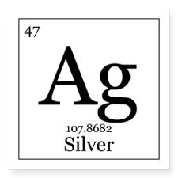
What is the atomic mass? __________
How many protons? ___________
How many electrons? __________
How many neutrons? ___________

- What is a chemical reaction?

- What is an ion?

  - How does an atom become a positive ion? ____________________
  - How does an atom become a negative ion?________________

- What is the difference between a covalent and ionic bond?

- Complete the table below:
Biomolecule | Monomer &  Examples | Polymer &  Examples
Carbohydrate
Lipid
Nucleic Acid
Protein

- What are three functions of proteins?

- What are two functions of lipids?

- What is the function of both carbohydrates and lipids?

- What is the process that breaks polymers apart called? Choose one polymer we discussed and describe the process including the products.

- What does biuret solution test for? What does a positive result look like?

- What does Iodine test for? What does a positive result look like?

- What does a Chemstrip test for? What does a positive result look like?

- What term describes the energy needed to get a reaction started?

- What effect do enzymes have on a reaction?

- What is the function of a catalyst?

- How are enzymes like a lock and key?

- True/False: Enzymes work best at a specific pH

- True/False: Enzymes work best at a specific
temperature

- True/False: Enzymes are proteins
- True/False: Each enzyme has a unique shape that
allows it to do its job

- At which temperature does enzyme A perform best?
Enzyme B?

- Knowing that one of these enzymes is found in humans and the other in thermophilic (heat-loving) bacteria, hypothesize which enzyme came from which organism.

