Name: __________________________

DNA & RNA Study Guide

What does DNA stand for?

What makes up a nucleotide?

What are the four bases of DNA? What are the base pairing rules?

Give the compliment strand for the following DNA strand:
A T C T A G T A C T A G

What are three differences & three similarities between RNA & DNA?

What sugar is found in DNA? What sugar is found in RNA?

Transcribe the following DNA strand into an mRNA strand:
A T C T A G T A C T A G

What are the three types of RNA and their functions?

Explain the process of DNA replication.
Why does DNA need to replicate?
What is a codon and where can it be found?
What are the two major types of mutations?

Fill in the table:
 | DNA Replication | Transcription | Translation
What is made?
What molecules are used?
Where in the cell does it take place?
What are the base pairing rules?

Be able to use the Codon Wheel to create a protein by determining what amino acid is being coded for and what the tRNA anticodons would be.
Example: mRNA: AUGCAGGCCGGAUGA

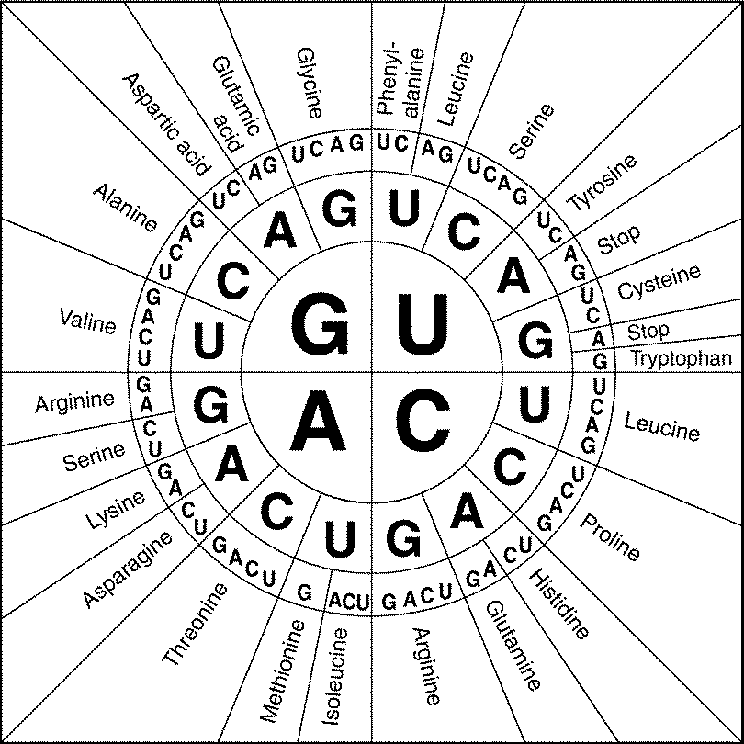

mRNA | AUG CAG GCC GGA CAU GCA UGA
Protein
tRNA

According to the Codon Wheel, what codons specify Leucine? Make sure you list ALL of them.

