Scientific Method
Use the following experiment to answer questions 1-7
A gardener was interested in helping her plants grow faster. When she went to the nursery, she found three fertilizers available for her plants. One of those fertilizers, fertilizer A, was recommended to her. However, she decided to conduct a test to determine which of the three fertilizers, if any, helped her plants grow fastest. The gardener planted four seeds, each in a separate pot. She used the same type of pot and the same type of soil in each pot. She fertilized one seed with fertilizer A, one with fertilizer B, and one with fertilizer C. She did not fertilize the fourth seed. She placed the four pots near one another in her garden. She made sure to give each plant the same amount of water each day. She measured the height of the plants each week and recorded her data. After eight weeks of careful observation and record-keeping, she had the data in Table 1.

- What was the problem she wanted to investigate?

- What was a possible hypothesis the gardener could have had?

- What was the independent variable?

- What was the dependent variable?

- List at least four constants.

- Which plant served as the control?

- Why is it important for her to have a control group?

What is Life?
Match the following statements to the appropriate Characteristics of Life.

- Made of cells
- Reproduce
- Genetic code
- Obtain and Use Energy
- Grow & Develop
- Respond to Environment
- Evolve
- Homeostasis

- _____ “Our cat had a litter of kittens last week.”
- _____ “At the beginning of summer my little sister couldn’t reach the light switch but now she can!”
- _____ “The Science Club looked at single-celled bacteria under the microscope yesterday.”
- _____ “If your blood sugar gets too high, your body will produce insulin to lower it.”
- _____ “My brother has brown hair, just like my mom.”
- _____ “Make sure to put the plant by the window so that it can get sunlight for photosynthesis.”
- _____ “The panda bear species now has a big wrist bone that they did not have 5000 years ago to help them grip bamboo.”
- _____ “Geese fly south for the winter.”

- Is the following an example of positive or negative feedback? EXPLAIN WHY.
Low calcium levels in the body stimulate cells to break down bone, increasing the amount of calcium.

- Is the following an example of positive or negative feedback? EXPLAIN WHY.
A cut on the skin stimulates the production of clotting factors. Clotting factors will continue to be produced in order to close the cut.

Genetics

- Which is easier to determine, someone’s genotype or someone’s phenotype? Explain.

- Determine the genotypes for each phenotype using the information provided.
A hitchhiker’s thumb (H) is dominant to a straight thumb (h)
Hitchhiker’s thumb _______________ Straight thumb _______________
- Using the alleles for hitchhiker’s thumb provided above (H, h), cross a homozygous recessive person with a person who is heterozygous.
What percent would have hitchhiker’s thumb?

What percent would have a straight thumb?

- Complete the following dihybird cross and provide the possible phenotypes and phenotypic ratio.
T = tall t = short R = round see r = wrinkled seed
TtRR x Ttrr
Possible Phenotypes:

Phenotypic Ratio:

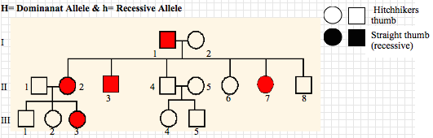

- Fill in the genotypes for each individual.

- If individual 8 in Generation II married a female with a straight thumb and had four children, what percent of their children would you expect to have a straight thumb? What percent of their children would you expect to have a hitchhiker’s thumb?

- Define and give an example of:
  - Codominance: ________________________________________________________
_______________________________________________________________________
_______________________________________________________________________

  - Polygenic trait: ________________________________________________________
________________________________________________________________________
________________________________________________________________________
  - Incomplete dominance: _________________________________________________
________________________________________________________________________________________________________________________________________________
  - Multiple alleles: _______________________________________________________
_______________________________________________________________________
_______________________________________________________________________

- What genotype represents a male: _________, female: __________?

- How many chromosomes are in a normal human karyotype? _____________

- How many alleles does each gene typically have? ____________

In tomato plants, the allele for red fruit color (R) is dominant to the allele for yellow fruit color (r). The allele for round-shaped fruit (F) is dominant to the allele for pear-shaped fruit (f).Two tomato plants, heterozygous for fruit color and fruit shape, are crossed. The Punnett square for this dihybrid cross is shown below.
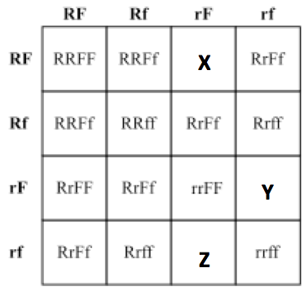

- Identify the genotype and phenotype for X, Y, and Z above.
 | Genotype | Phenotype
X
Y
Z

- According to the dihybrid cross above, how many offspring would be:

- Red fruit & round shape:
- Red fruit & pear shape:
- Yellow fruit & round shape:
- Yellow fruit & pear shape:
- A man with type BO blood marries a woman with type AO blood, what blood types could their children have?

Molecular Genetics

1. What are the nucleotides of DNA made up of? What are the four bases of DNA? What are the base pairing rules?

2. What are the nucleotides of RNA made up of? What are the four bases of RNA? What are the base pairing rules?

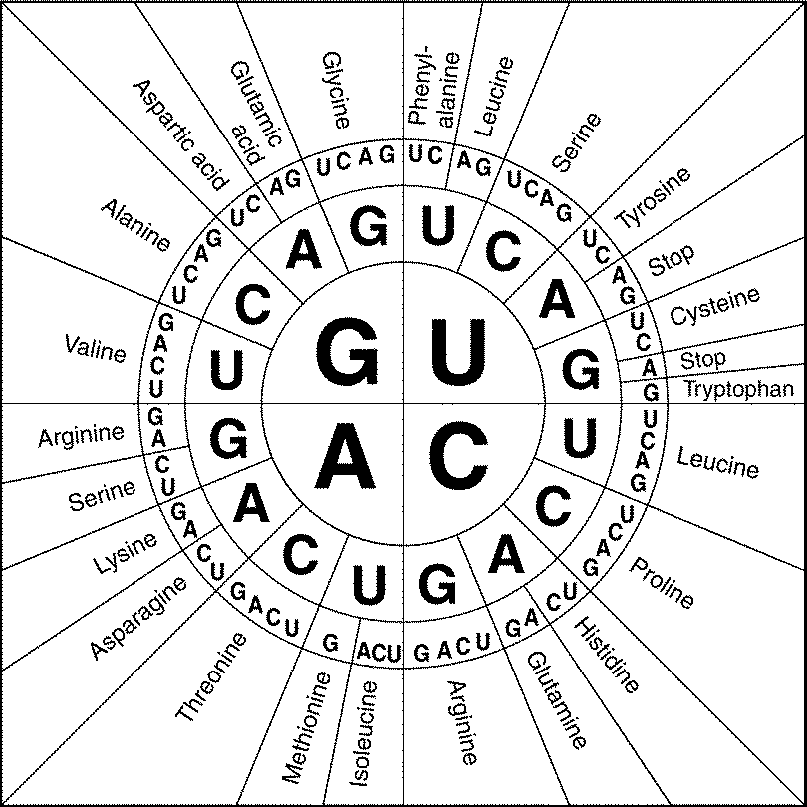
3. Give the compliment strand for the following DNA strand:
A T C T A G T A C T A G

4. Transcribe the following DNA strand into an mRNA strand:
A T C T A G T A C T A G

5. Translate the following mRNA into a protein sequence.
AUG GGU CCA UGG ACA UAA

